**Prototype Assignment – G1**

Due Date :

Group Members :

Ido Kadosh 301727277

Lee Hugi 311178552

Itay David 308021591

Raviv Komem 316217751

Lior Kauffman 315837997

The supervisor can access to this page, and able to watch all of the processes their creation date, description, ID and status.

Refresh button,incase status updated, or a new change request submitted

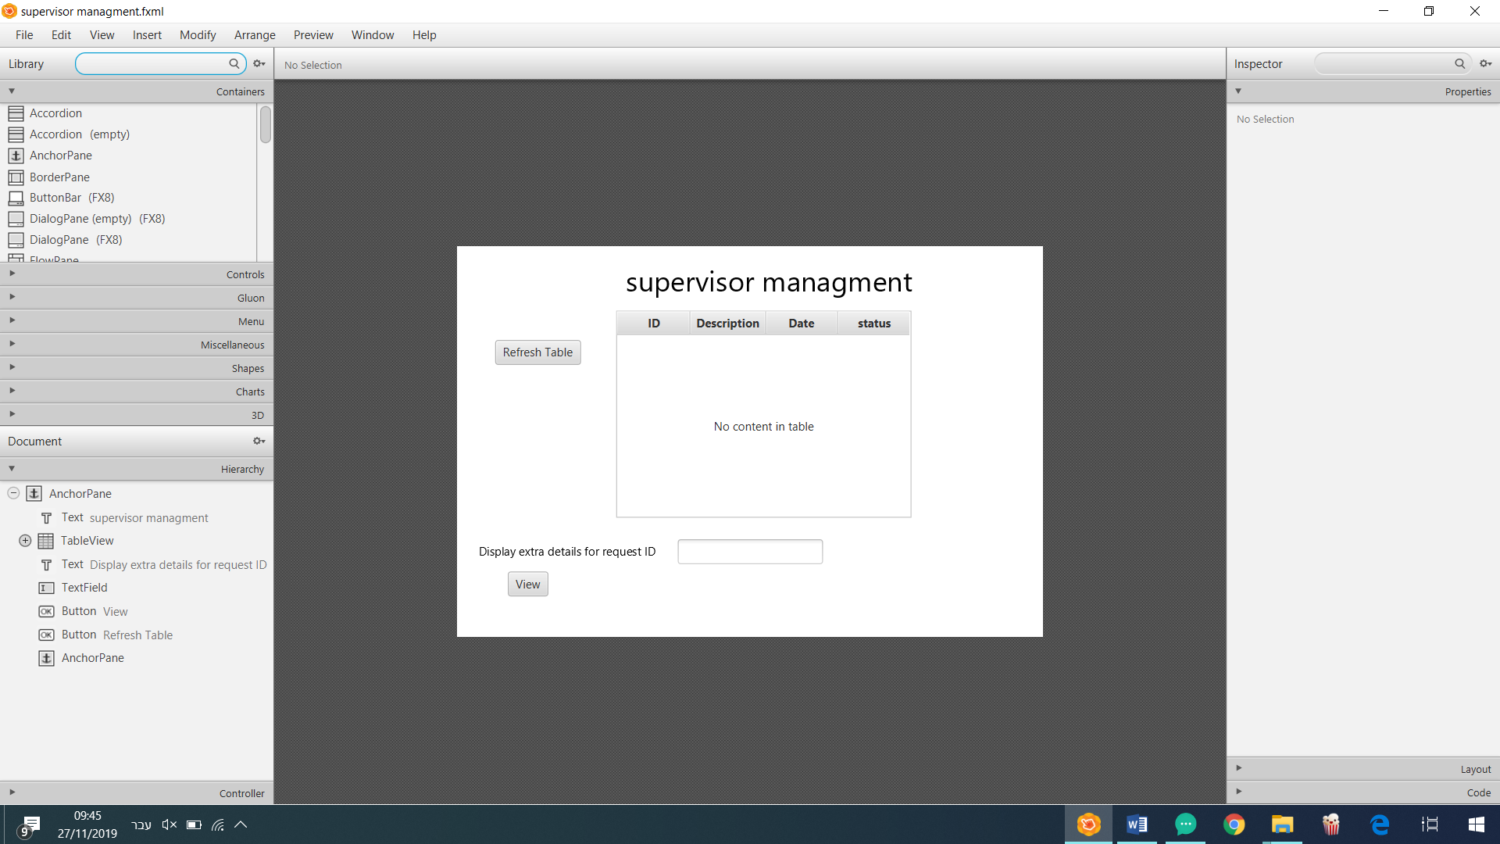

In case the supervisor needs extra details about a specific change request, enters the specific ID and press the view button.

In case the ID number is wrong it will show an error message and wait for a valid ID.

The supervisor can freeze/unfreeze the "Change request". by using buttons

Shows the specific "Change request" with extra details

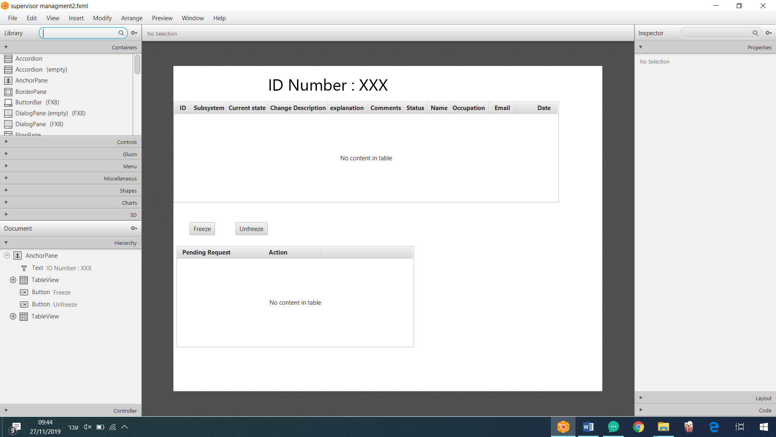

For each "Change request" display the requests that waiting for approval by the supervisor with the necessary buttons.

The requested amount of days that necessary, and the reason.

Incase this is not the first time that time extension has been made, submitted without reason or asked for more than 3 days.

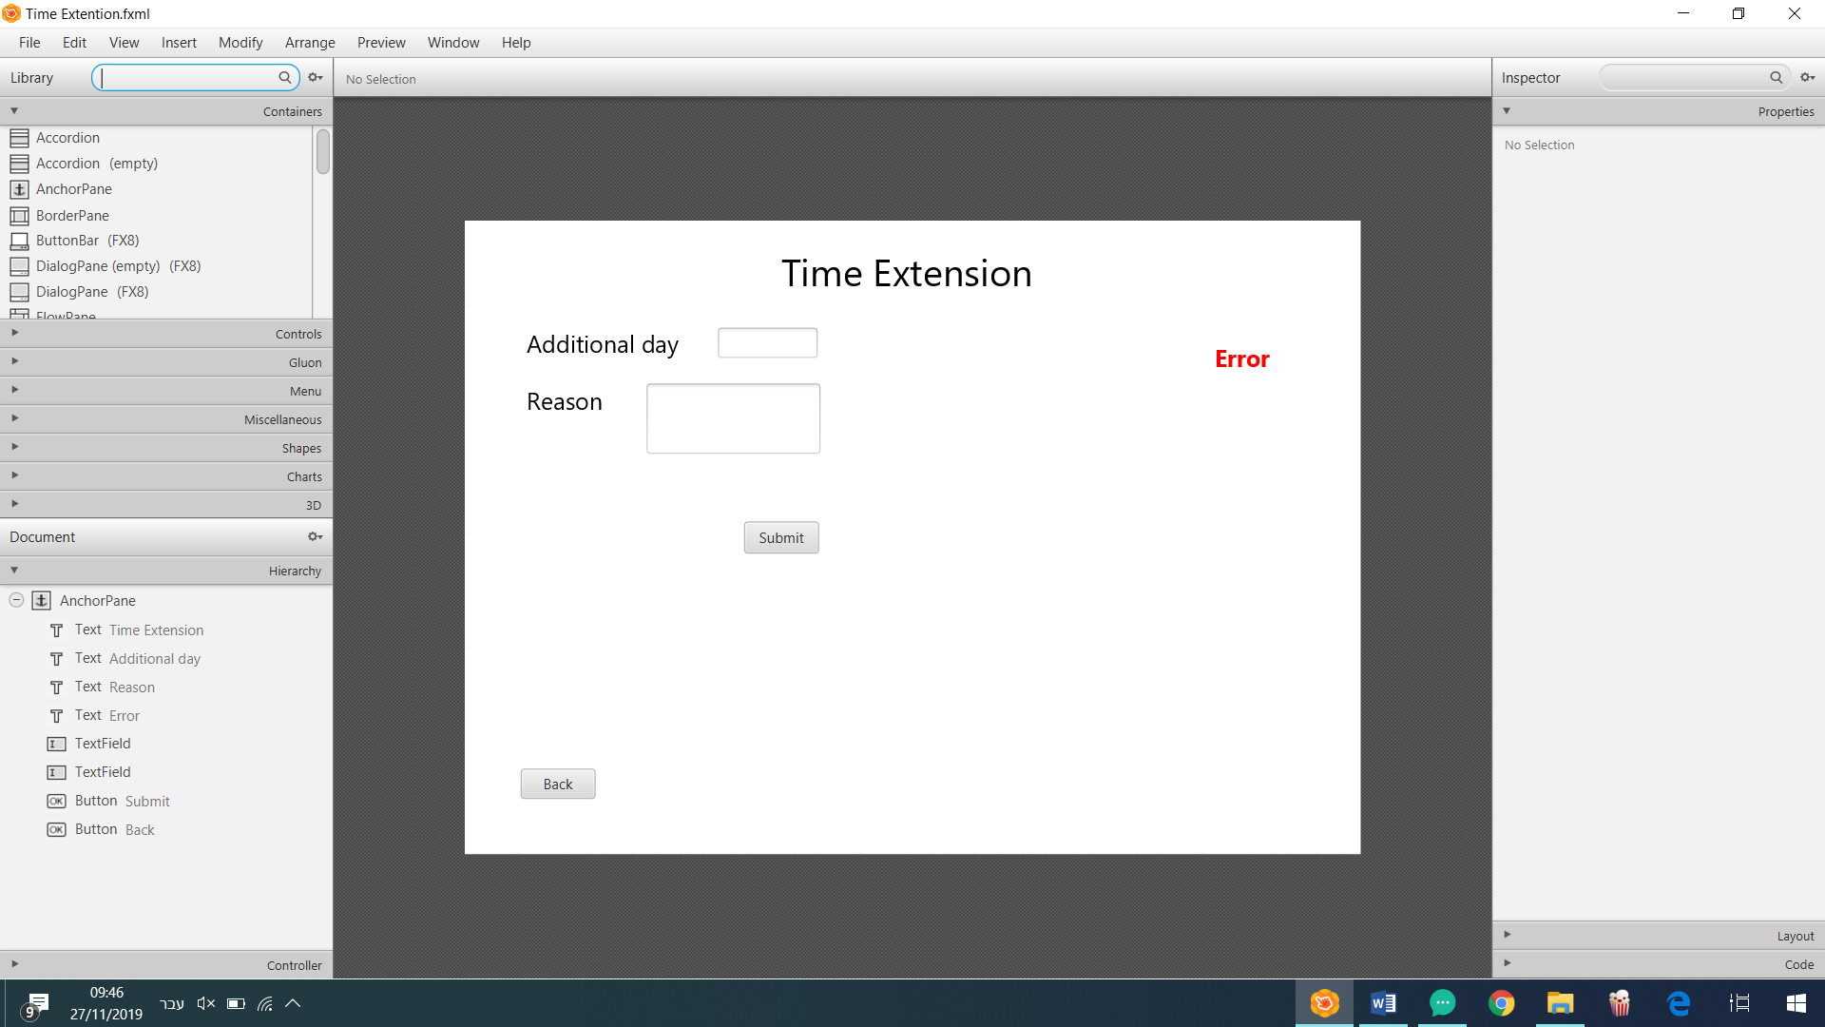

In case want to go back to previous page

After all the required fields are filled

Enter request ID to test the change committed and press the view button

In case the ID is wrong

The tester can watch the analysis report.

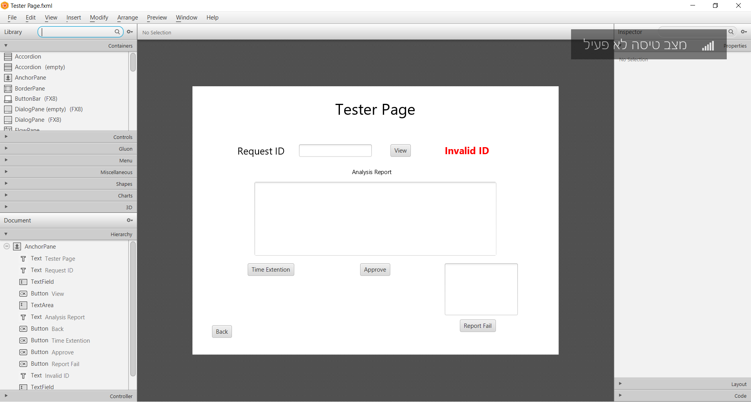

Report test failure with an explanation

Approve the changes

Ask for time extension

Enter a valid request ID to execute the requested change, and press the view button

In case the ID is wrong, shows message, and wait for a valid ID

In case wants to go back to previous page.

The execution leader can review the analysis report.

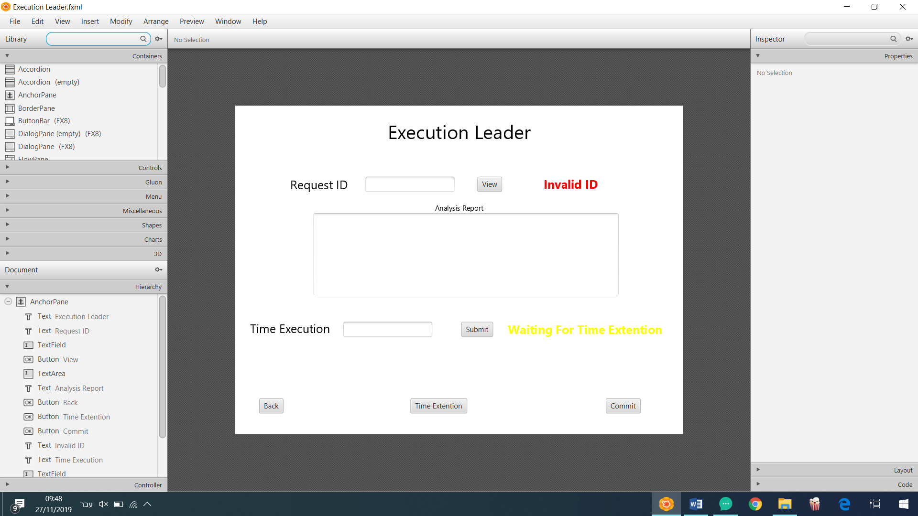

Message will show after the execution leader submit the request for time execution and waits for the supervisor approval

Determining the duration time to execute the requested change, then press submit button

In case the execution leader need an extra time to execute the change, than press submit

After the execution complete

To display the change request status, enter a valid ID and press view button.

In case the ID is wrong show this message.

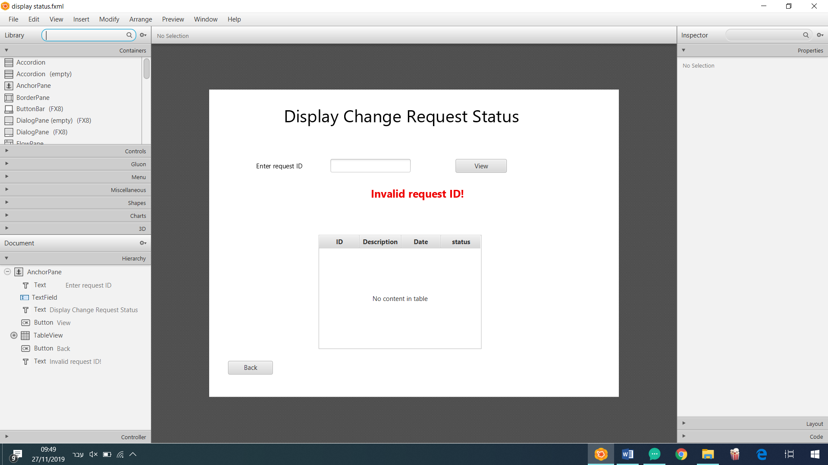

Displaying the "change request" status with the additional fields ID, Description and Date

Any committee member can watch the other comments, and use the refresh button to check if the table updated.

Only The committee members can access this page, enter a valid ID and press view button to continue.

Each of the committee members add his comment for the requested change and press submit button.

In case insert invalid ID

Shows the remaining time for this step.

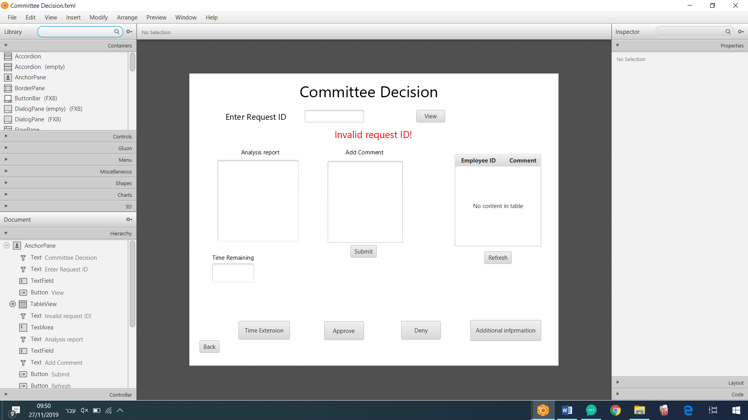

In case the committee approved the "change request"

In case the committee denied the "change request".

In case the committee members need an additional information for make their decision the committee director can ask for more information by pressing this button.

In case the committee members need more time to complete this phase, the committee director can ask for time extension

In case the committee members wants to go to the previous page